Министерство образования и науки Украины

Национальный технический университет Украины

«Киевский политехнический институт»

Факультет прикладной математики

Кафедра системного программирования и специализированых компьютерных систем

Расчётно-графическая работа

по дисциплине «Дискретная математика»

Выполнил: Тименко Антон Александрович

Студент группы КВ-32

Вариант №61

Оценка: _________

г. Киев

2014

Задание №1

Решить уравнение , где в алгебре множеств. При решении использовать алгебраический метод. В качестве неизвестного принимается множество, обозначаемое символом .

Решение

;

;

;

;

;

;

;

;

Подставим :

;

;

ОТВЕТ: .

Задание №2

Граф задан матрицей смежности:

|  |  |  |  |  |  |  |  |  |
| --- | --- | --- | --- | --- | --- | --- | --- | --- |
|  | 1 | 2 | 3 | 4 | 5 | 6 | 7 | 8 |
| 1 | 1 | 1 | 1 |  | 1 | 1 | 1 |  |
| 2 |  |  | 1 | 1 |  |  |  |  |
| 3 | 1 | 1 | 1 |  | 1 |  |  |  |
| 4 | 1 | 1 |  |  |  |  | 1 | 1 |
| 5 | 1 |  |  |  | 1 |  |  |  |
| 6 |  | 1 |  | 1 |  |  |  |  |
| 7 |  | 1 | 1 |  |  |  | 1 | 1 |
| 8 |  | 1 | 1 | 1 | 1 |  | 1 |  |

Построим граф:

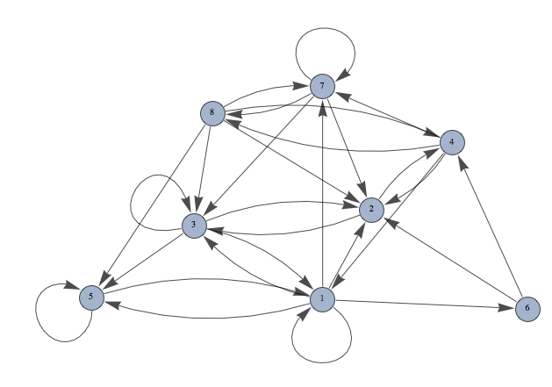

2.1: Выполнить разложение орграфа на компоненты сильной связности методом Мальгранжа-Томеску.

|  |  |  |  |  |  |  |  |  |  |  |
| --- | --- | --- | --- | --- | --- | --- | --- | --- | --- | --- |
|  | 1 | 2 | 3 | 4 | 5 | 6 | 7 | 8 |  |  |
| 1 | 1 | 1 | 1 |  | 1 | 1 | 1 |  |  | 0 |
| 2 |  |  | 1 | 1 |  |  |  |  |  | 1 |
| 3 | 1 | 1 | 1 |  | 1 |  |  |  |  | 2 |
| 4 | 1 | 1 |  |  |  |  | 1 | 1 |  | 2 |
| 5 | 1 |  |  |  | 1 |  |  |  |  | 3 |
| 6 |  | 1 |  | 1 |  |  |  |  |  | 1 |
| 7 |  | 1 | 1 |  |  |  | 1 | 1 |  | 3 |
| 8 |  | 1 | 1 | 1 | 1 |  | 1 |  |  | 4 |
|  |  |  |  |  |  |  |  |  |  |  |
|  | 0 | 2 | 1 | 3 | 1 | 4 | 5 | 4 |  |  |

;

;

.

Весь граф является компонентой сильной связности.

2.2: Найти методами Магу все внутренне устойчивые множества вершин графа, все внешне устойчивые множества вершин графа, ядра графа.

Найдем внутренне устойчивые множества.

|  |  |  |  |  |  |  |  |  |
| --- | --- | --- | --- | --- | --- | --- | --- | --- |
|  | 1 | 2 | 3 | 4 | 5 | 6 | 7 | 8 |
| 1 | 1 | 1 | 1 |  | 1 | 1 | 1 |  |
| 2 |  |  | 1 | 1 |  |  |  |  |
| 3 | 1 | 1 | 1 |  | 1 |  |  |  |
| 4 | 1 | 1 |  |  |  |  | 1 | 1 |
| 5 | 1 |  |  |  | 1 |  |  |  |
| 6 |  | 1 |  | 1 |  |  |  |  |
| 7 |  | 1 | 1 |  |  |  | 1 | 1 |
| 8 |  | 1 | 1 | 1 | 1 |  | 1 |  |

Внутренне устойчивые множества:

Число внутренней устойчивости графа: .

Найдем внешне устойчивые множества.

Внешне устойчивые множества:

Число внешней устойчивости графа: .

Ядер у данного графа нет, так как нет такого подмножества вершин, которое одновременно являлось бы максимальным внутренне и минимально внешне устойчивым.

2.3: Найти цикломатическое число и построить матрицу фундаментальных циклов графа. Построить три нефундаментальных цикла графа.

Превратим наш граф в неограф. Построим его:

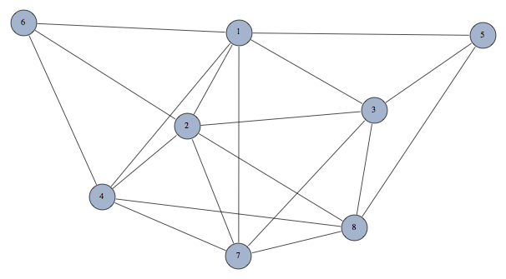

Матрица смежности для нашего неографа:

|  |  |  |  |  |  |  |  |  |
| --- | --- | --- | --- | --- | --- | --- | --- | --- |
|  | 1 | 2 | 3 | 4 | 5 | 6 | 7 | 8 |
| 1 |  | 1 | 1 | 1 | 1 | 1 | 1 |  |
| 2 | 1 |  | 1 | 1 |  | 1 | 1 | 1 |
| 3 | 1 | 1 |  |  | 1 |  | 1 | 1 |
| 4 | 1 | 1 |  |  |  | 1 | 1 | 1 |
| 5 | 1 |  | 1 |  |  |  |  | 1 |
| 6 | 1 | 1 |  | 1 |  |  |  |  |
| 7 | 1 | 1 | 1 | 1 |  |  |  | 1 |
| 8 |  | 1 | 1 | 1 | 1 |  | 1 |  |

Цикломатическое число графа:

Построим остов графа:

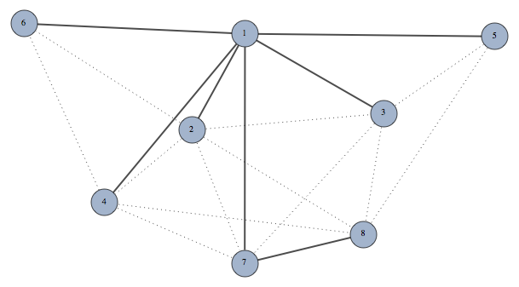

Построем матрицу фундаментальных циклов:

|  |  |  |  |  |  |  |  |  |  |  |  |  |  |  |  |  |  |  |  |
| --- | --- | --- | --- | --- | --- | --- | --- | --- | --- | --- | --- | --- | --- | --- | --- | --- | --- | --- | --- |
|  | 23 | 24 | 26 | 27 | 28 | 35 | 37 | 38 | 46 | 47 | 48 | 58 | 12 | 13 | 14 | 15 | 16 | 17 | 78 |
|  | 1 |  |  |  |  |  |  |  |  |  |  |  | 1 | 1 |  |  |  |  |  |
|  |  | 1 |  |  |  |  |  |  |  |  |  |  | 1 |  | 1 |  |  |  |  |
|  |  |  | 1 |  |  |  |  |  |  |  |  |  | 1 |  |  |  | 1 |  |  |
|  |  |  |  | 1 |  |  |  |  |  |  |  |  | 1 |  |  |  |  | 1 |  |
|  |  |  |  |  | 1 |  |  |  |  |  |  |  | 1 |  |  |  |  | 1 | 1 |
|  |  |  |  |  |  | 1 |  |  |  |  |  |  |  | 1 |  | 1 |  |  |  |
|  |  |  |  |  |  |  | 1 |  |  |  |  |  |  | 1 |  |  |  | 1 |  |
|  |  |  |  |  |  |  |  | 1 |  |  |  |  |  | 1 |  |  |  | 1 | 1 |
|  |  |  |  |  |  |  |  |  | 1 |  |  |  |  |  | 1 |  | 1 |  |  |
|  |  |  |  |  |  |  |  |  |  | 1 |  |  |  |  | 1 |  |  | 1 |  |
|  |  |  |  |  |  |  |  |  |  |  | 1 |  |  |  | 1 |  |  | 1 | 1 |
|  |  |  |  |  |  |  |  |  |  |  |  | 1 |  |  |  | 1 |  | 1 | 1 |
|  |  |  |  |  |  |  |  |  |  |  |  |  |  |  |  |  |  |  |  |
|  | 1 |  |  |  |  | 1 |  |  |  |  |  |  | 1 |  |  | 1 |  |  |  |
|  |  | 1 |  |  |  |  |  |  |  |  | 1 |  | 1 |  |  |  |  | 1 | 1 |
|  |  |  |  | 1 |  |  | 1 |  |  |  |  |  | 1 | 1 |  |  |  |  |  |

:

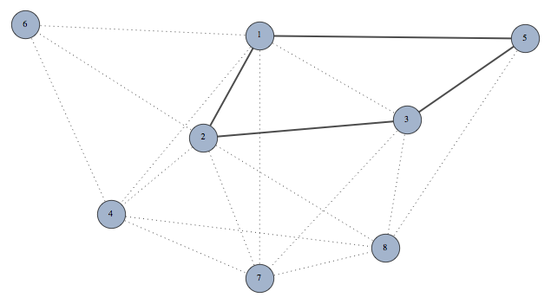

:

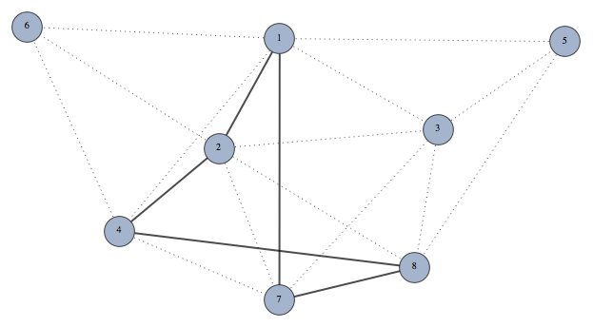

:

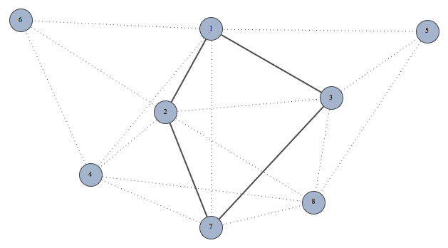

2.4: Построить матрицу фундаментальных разрезов графа. Построить три нефундаментальных разреза графа.

|  |  |  |  |  |  |  |  |  |  |  |  |  |  |  |  |  |  |  |  |
| --- | --- | --- | --- | --- | --- | --- | --- | --- | --- | --- | --- | --- | --- | --- | --- | --- | --- | --- | --- |
|  | 23 | 24 | 26 | 27 | 28 | 35 | 37 | 38 | 46 | 47 | 48 | 58 | 12 | 13 | 14 | 15 | 16 | 17 | 78 |
|  | 1 | 1 | 1 | 1 | 1 |  |  |  |  |  |  |  | 1 |  |  |  |  |  |  |
|  | 1 |  |  |  |  | 1 | 1 | 1 |  |  |  |  |  | 1 |  |  |  |  |  |
|  |  | 1 |  |  |  |  |  |  | 1 | 1 | 1 |  |  |  | 1 |  |  |  |  |
|  |  |  |  |  |  | 1 |  |  |  |  |  | 1 |  |  |  | 1 |  |  |  |
|  |  |  | 1 |  |  |  |  |  | 1 |  |  |  |  |  |  |  | 1 |  |  |
|  |  |  |  | 1 | 1 |  | 1 | 1 |  | 1 | 1 | 1 |  |  |  |  |  | 1 |  |
|  |  |  |  |  | 1 |  |  | 1 |  |  | 1 | 1 |  |  |  |  |  |  | 1 |
|  |  |  |  |  |  |  |  |  |  |  |  |  |  |  |  |  |  |  |  |
|  |  | 1 | 1 | 1 | 1 | 1 | 1 | 1 |  |  |  |  | 1 | 1 |  |  |  |  |  |
|  |  |  | 1 |  |  | 1 |  |  | 1 |  |  | 1 |  |  |  | 1 | 1 |  |  |
|  |  |  |  | 1 |  |  | 1 |  |  | 1 |  |  |  |  |  |  |  | 1 | 1 |

:

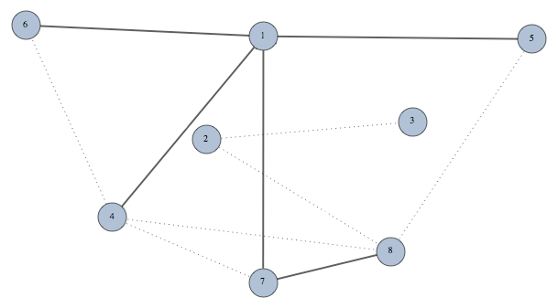

:

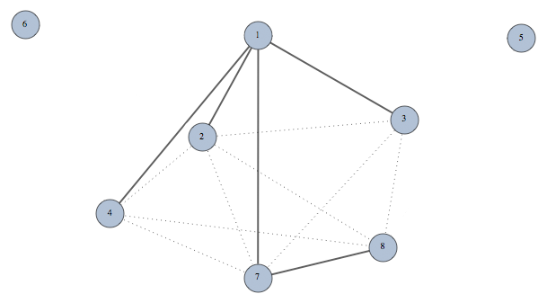

:

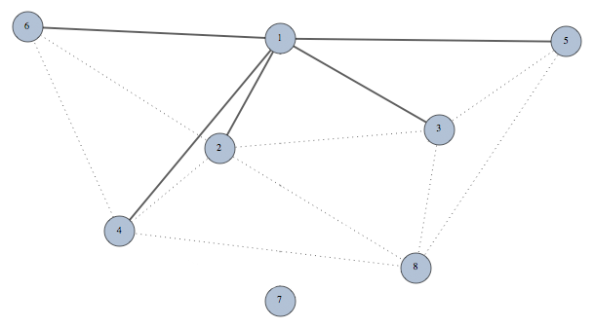

2.5: Произвести раскраску вершин графа, используя функцию Гранди.

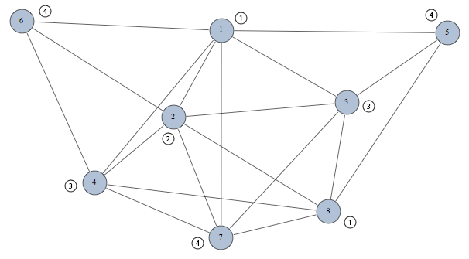

Приблизительное хроматическое число графа G: .

2.6: Найти методом точного поиска хроматическое число графа.

|  |  |  |  |  |  |  |  |  |
| --- | --- | --- | --- | --- | --- | --- | --- | --- |
|  | 1 | 2 | 3 | 4 | 5 | 6 | 7 | 8 |
| 1 |  | 1 | 1 | 1 | 1 | 1 | 1 |  |
| 2 | 1 |  | 1 | 1 |  | 1 | 1 | 1 |
| 3 | 1 | 1 |  |  | 1 |  | 1 | 1 |
| 4 | 1 | 1 |  |  |  | 1 | 1 | 1 |
| 5 | 1 |  | 1 |  |  |  |  | 1 |
| 6 | 1 | 1 |  | 1 |  |  |  |  |
| 7 | 1 | 1 | 1 | 1 |  |  |  | 1 |
| 8 |  | 1 | 1 | 1 | 1 |  | 1 |  |

Найдем внутренне устойчивые множества:

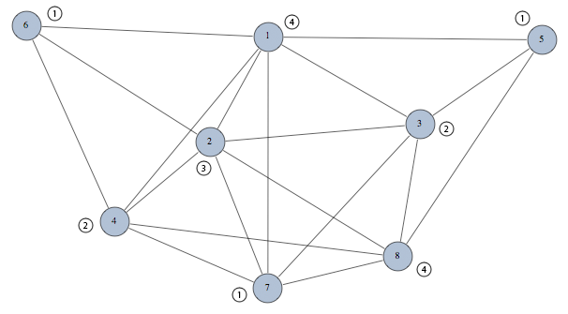

Точное хроматическое число графа: .

Задание №3

Решить задачу коммивояжера для данной матрицы расстояний.

Матрица:

|  |  |  |  |  |  |  |  |  |
| --- | --- | --- | --- | --- | --- | --- | --- | --- |
|  | 1 | 2 | 3 | 4 | 5 | 6 | 7 | 8 |
| 1 | ∞ | 16 | 14 | 18 | 20 | 9 | 46 | 25 |
| 2 | 17 | ∞ | 42 | 72 | 61 | 18 | 8 | 50 |
| 3 | 30 | 27 | ∞ | 27 | 21 | 18 | 39 | 9 |
| 4 | 63 | 35 | 65 | ∞ | 72 | 81 | 42 | 31 |
| 5 | 18 | 27 | 15 | 45 | ∞ | 36 | 15 | 12 |
| 6 | 32 | 16 | 25 | 28 | 42 | ∞ | 12 | 10 |
| 7 | 94 | 22 | 21 | 42 | 18 | 17 | ∞ | 43 |
| 8 | 16 | 22 | 28 | 27 | 30 | 31 | 52 | ∞ |

Решение:

Шаг №1

|  |  |  |  |  |  |  |  |  |  |  |  |  |  |  |  |  |  |  |  |  |
| --- | --- | --- | --- | --- | --- | --- | --- | --- | --- | --- | --- | --- | --- | --- | --- | --- | --- | --- | --- | --- |
|  | 1 | 2 | 3 | 4 | 5 | 6 | 7 | 8 |  |  |  |  | 1 | 2 | 3 | 4 | 5 | 6 | 7 | 8 |
| 1 | ∞ | 7 | 5 | 9 | 11 | 0 | 37 | 16 |  | 9 |  | 1 | ∞ | 3 | 2 | 0 | 10 | 0 | 37 | 16 |
| 2 | 9 | ∞ | 34 | 64 | 53 | 10 | 0 | 42 |  | 8 |  | 2 | 9 | ∞ | 31 | 55 | 52 | 10 | 0 | 42 |
| 3 | 21 | 18 | ∞ | 18 | 12 | 9 | 30 | 0 |  | 9 |  | 3 | 21 | 14 | ∞ | 9 | 11 | 9 | 30 | 0 |
| 4 | 32 | 4 | 34 | ∞ | 41 | 50 | 11 | 0 |  | 31 |  | 4 | 32 | 0 | 31 | ∞ | 40 | 50 | 11 | 0 |
| 5 | 6 | 15 | 3 | 33 | ∞ | 24 | 3 | 0 |  | 12 |  | 5 | 6 | 11 | 0 | 24 | ∞ | 24 | 3 | 0 |
| 6 | 22 | 6 | 15 | 18 | 32 | ∞ | 2 | 0 |  | 10 |  | 6 | 22 | 2 | 12 | 9 | 31 | ∞ | 2 | 0 |
| 7 | 77 | 5 | 4 | 25 | 1 | 0 | ∞ | 26 |  | 17 |  | 7 | 77 | 1 | 1 | 16 | 0 | 0 | ∞ | 26 |
| 8 | 0 | 6 | 12 | 11 | 14 | 15 | 36 | ∞ |  | 16 |  | 8 | 0 | 2 | 9 | 2 | 13 | 15 | 36 | ∞ |
|  |  |  |  |  |  |  |  |  |  |  |  |  |  |  |  |  |  |  |  |  |
|  |  |  |  |  |  |  |  |  |  |  |  |  | 0 | 4 | 3 | 9 | 1 | 0 | 0 | 0 |

|  |  |  |  |
| --- | --- | --- | --- |
| Нулевые клетки | Вычитаемое число | | Сумма |
| строки | столбца |
| (1,4) | 0 | 2 | 2 |
| (1,6) | 0 | 0 | 0 |
| (2,7) | 9 | 2 | 11 |
| (3,8) | 9 | 0 | 9 |
| (4,2) | 0 | 1 | 1 |
| (4,8) | 0 | 0 | 0 |
| (5,3) | 0 | 1 | 1 |
| (5,8) | 0 | 0 | 0 |
| (6,8) | 2 | 0 | 2 |
| (7,5) | 0 | 10 | 10 |
| (7,6) | 0 | 0 | 0 |
| (8,1) | 2 | 6 | 8 |

Шаг №2

|  |  |  |  |  |  |  |  |
| --- | --- | --- | --- | --- | --- | --- | --- |
|  | 1 | 2 | 3 | 4 | 5 | 6 | 8 |
| 1 | ∞ | 3 | 2 | 0 | 10 | 0 | 16 |
| 3 | 21 | 14 | ∞ | 9 | 11 | 9 | 0 |
| 4 | 32 | 0 | 31 | ∞ | 40 | 50 | 0 |
| 5 | 6 | 11 | 0 | 24 | ∞ | 24 | 0 |
| 6 | 22 | 2 | 12 | 9 | 31 | ∞ | 0 |
| 7 | 77 | ∞ | 1 | 16 | 0 | 0 | 26 |
| 8 | 0 | 2 | 9 | 2 | 13 | 15 | ∞ |

|  |  |  |  |
| --- | --- | --- | --- |
| Нулевые клетки | Вычитаемое число | | Сумма |
| строки | столбца |
| (1,4) | 0 | 2 | 2 |
| (1,6) | 0 | 0 | 0 |
| (3,8) | 9 | 0 | 9 |
| (4,2) | 0 | 2 | 2 |
| (4,8) | 0 | 0 | 0 |
| (5,3) | 0 | 1 | 1 |
| (5,8) | 0 | 0 | 0 |
| (6,8) | 2 | 0 | 2 |
| (7,5) | 0 | 10 | 10 |
| (7,6) | 0 | 0 | 0 |
| (8,1) | 2 | 6 | 8 |

Шаг №3

**(1)**

|  |  |  |  |  |  |  |
| --- | --- | --- | --- | --- | --- | --- |
|  | 1 | 2 | 3 | 4 | 6 | 8 |
| 1 | ∞ | 3 | 2 | 0 | 0 | 16 |
| 3 | 21 | 14 | ∞ | 9 | 9 | 0 |
| 4 | 32 | 0 | 31 | ∞ | 50 | 0 |
| 5 | 6 | ∞ | 0 | 24 | 24 | 0 |
| 6 | 22 | 2 | 12 | 9 | ∞ | 0 |
| 8 | 0 | 2 | 9 | 2 | 15 | ∞ |

**(2)**

|  |  |  |  |  |  |  |
| --- | --- | --- | --- | --- | --- | --- |
|  | 1 | 2 | 3 | 4 | 6 | 8 |
| 1 | ∞ | 3 | 2 | 0 | 0 | 16 |
| 3 | 21 | 14 | ∞ | 9 | 9 | 0 |
| 4 | 32 | 0 | 31 | ∞ | 50 | 0 |
| 5 | 6 | ∞ | 0 | 24 | 24 | 0 |
| 6 | 22 | 2 | 12 | 9 | ∞ | 0 |
| 8 | 0 | 2 | 9 | 2 | 15 | ∞ |

|  |  |  |  |  |
| --- | --- | --- | --- | --- |
| Нулевые клетки | Вычитаемое число | | Сумма |  |
| строки | столбца |  |
| (1,4) | 0 | 2 | 2 |  |
| (1,6) | 0 | 9 | 9 | **(2)** |
| (3,8) | 9 | 0 | 9 | **(1)** |
| (4,2) | 0 | 2 | 2 |  |
| (4,8) | 0 | 0 | 0 |  |
| (5,3) | 0 | 2 | 2 |  |
| (5,8) | 0 | 0 | 0 |  |
| (6,8) | 2 | 0 | 2 |  |
| (8,1) | 2 | 6 | 8 |  |

Шаг №4-1

|  |  |  |  |  |  |  |  |  |  |  |  |  |  |  |
| --- | --- | --- | --- | --- | --- | --- | --- | --- | --- | --- | --- | --- | --- | --- |
|  | 1 | 2 | 3 | 4 | 6 |  |  | 1 | 2 | 3 | 4 | 6 |  |  |
| 1 | ∞ | 3 | 2 | 0 | 0 |  | 1 | ∞ | 3 | 2 | 0 | 0 |  | 0 |
| 4 | 32 | 0 | 31 | ∞ | 50 |  | 4 | 32 | 0 | 31 | ∞ | 50 |  | 0 |
| 5 | 6 | ∞ | 0 | 24 | 24 |  | 5 | 6 | ∞ | 0 | 24 | 24 |  | 0 |
| 6 | 22 | 2 | 12 | 9 | ∞ |  | 6 | 20 | 0 | 10 | 7 | ∞ |  | 2 |
| 8 | 0 | 2 | ∞ | 2 | 15 |  | 8 | 0 | 2 | ∞ | 2 | 15 |  | 0 |

|  |  |  |  |
| --- | --- | --- | --- |
| Нулевые клетки | Вычитаемое число | | Сумма |
| строки | столбца |
| (1,4) | 0 | 2 | 2 |
| (1,6) | 0 | 15 | 15 |
| (4,2) | 31 | 0 | 31 |
| (5,3) | 6 | 2 | 8 |
| (6,2) | 7 | 0 | 7 |
| (8,1) | 2 | 6 | 8 |

Шаг №5-1

|  |  |  |  |  |  |  |  |  |  |  |  |  |
| --- | --- | --- | --- | --- | --- | --- | --- | --- | --- | --- | --- | --- |
|  | 1 | 3 | 4 | 6 |  |  | 1 | 3 | 4 | 6 |  |  |
| 1 | ∞ | 2 | 0 | 0 |  | 1 | ∞ | 2 | 0 | 0 |  | 0 |
| 5 | 6 | 0 | ∞ | 24 |  | 5 | 6 | 0 | ∞ | 24 |  | 0 |
| 6 | 20 | 10 | 7 | ∞ |  | 6 | 13 | 3 | 0 | ∞ |  | 7 |
| 8 | 0 | ∞ | 2 | 15 |  | 8 | 0 | ∞ | 2 | 15 |  | 0 |

|  |  |  |  |
| --- | --- | --- | --- |
| Нулевые клетки | Вычитаемое число | | Сумма |
| строки | столбца |
| (1,4) | 0 | 0 | 0 |
| (1,6) | 0 | 15 | 15 |
| (5,3) | 6 | 2 | 8 |
| (6,4) | 3 | 0 | 3 |
| (8,1) | 2 | 6 | 8 |

Шаг №6-1

|  |  |  |  |
| --- | --- | --- | --- |
|  | 1 | 3 | 4 |
| 5 | 6 | 0 | ∞ |
| 6 | ∞ | 3 | 0 |
| 8 | 0 | ∞ | 2 |

|  |  |  |  |
| --- | --- | --- | --- |
| Нулевые клетки | Вычитаемое число | | Сумма |
| строки | столбца |
| (5,3) | 6 | 3 | 9 |
| (6,4) | 3 | 2 | 5 |
| (8,1) | 2 | 6 | 8 |

Шаг №7-1

|  |  |  |
| --- | --- | --- |
|  | 1 | 4 |
| 6 | ∞ | 0 |
| 8 | 0 | ∞ |

Шаг №4-2

|  |  |  |  |  |  |  |  |  |  |  |  |  |
| --- | --- | --- | --- | --- | --- | --- | --- | --- | --- | --- | --- | --- |
|  | 1 | 2 | 3 | 4 | 8 |  |  | 1 | 2 | 3 | 4 | 8 |
| 3 | 21 | 14 | ∞ | 9 | 0 |  | 3 | 21 | 14 | ∞ | 7 | 0 |
| 4 | 32 | 0 | 31 | ∞ | 0 |  | 4 | 32 | 0 | 31 | ∞ | 0 |
| 5 | 6 | ∞ | 0 | 24 | 0 |  | 5 | 6 | ∞ | 0 | 22 | 0 |
| 6 | ∞ | 2 | 12 | 9 | 0 |  | 6 | ∞ | 2 | 12 | 7 | 0 |
| 8 | 0 | 2 | 9 | 2 | ∞ |  | 8 | 0 | 2 | 9 | 0 | ∞ |
|  |  |  |  |  |  |  |  |  |  |  |  |  |
|  |  |  |  |  |  |  |  | 0 | 0 | 0 | 2 | 0 |

|  |  |  |  |
| --- | --- | --- | --- |
| Нулевые клетки | Вычитаемое число | | Сумма |
| строки | столбца |
| (3,8) | 7 | 0 | 7 |
| (4,2) | 0 | 2 | 2 |
| (4,8) | 0 | 0 | 0 |
| (5,3) | 0 | 9 | 9 |
| (5,8) | 0 | 0 | 0 |
| (6,8) | 2 | 0 | 2 |
| (8,1) | 0 | 6 | 6 |
| (8,4) | 0 | 7 | 7 |

Шаг №5-2

|  |  |  |  |  |
| --- | --- | --- | --- | --- |
|  | 1 | 2 | 4 | 8 |
| 3 | 21 | ∞ | 7 | 0 |
| 4 | 32 | 0 | ∞ | 0 |
| 6 | ∞ | 2 | 7 | 0 |
| 8 | 0 | 2 | 0 | ∞ |

|  |  |  |  |
| --- | --- | --- | --- |
| Нулевые клетки | Вычитаемое число | | Сумма |
| строки | столбца |
| (3,8) | 7 | 0 | 7 |
| (4,2) | 0 | 2 | 2 |
| (4,8) | 0 | 0 | 0 |
| (6,8) | 2 | 0 | 2 |
| (8,1) | 0 | 21 | 21 |
| (8,4) | 0 | 7 | 7 |

Шаг №6-2

|  |  |  |  |  |  |  |  |  |  |  |  |  |  |  |  |
| --- | --- | --- | --- | --- | --- | --- | --- | --- | --- | --- | --- | --- | --- | --- | --- |
|  | 2 | 4 | 8 |  |  | 2 | 4 | 8 |  |  |  |  | 2 | 4 | 8 |
| 3 | ∞ | 7 | 0 |  | 3 | ∞ | 7 | 0 |  | 0 |  | 3 | ∞ | 2 | 0 |
| 4 | 0 | ∞ | 0 |  | 4 | 0 | ∞ | 0 |  | 0 |  | 4 | 0 | ∞ | 0 |
| 6 | 2 | 7 | ∞ |  | 6 | 0 | 5 | ∞ |  | 2 |  | 6 | 0 | 0 | ∞ |
|  |  |  |  |  |  |  |  |  |  |  |  |  |  |  |  |
|  |  |  |  |  |  |  |  |  |  |  |  |  | 0 | 5 | 0 |

|  |  |  |  |
| --- | --- | --- | --- |
|  | 2 | 4 | 8 |
| 3 | ∞ | 2 | 0 |
| 4 | 0 | ∞ | 0  **(1)** |
| 6 | 0 | 0 | ∞ |

|  |  |  |  |
| --- | --- | --- | --- |
|  | 2 | 4 | 8 |
| 3 | ∞ | 2 | 0  **(2)** |
| 4 | 0 | ∞ | 0 |
| 6 | 0 | 0 | ∞ |

|  |  |  |  |  |
| --- | --- | --- | --- | --- |
| Нулевые клетки | Вычитаемое число | | Сумма |  |
| строки | столбца |  |
| (3,8) | 2 | 0 | 2 | **(1)** |
| (4,2) | 0 | 0 | 0 |  |
| (4,8) | 0 | 0 | 0 |  |
| (6,2) | 0 | 0 | 0 |  |
| (6,4) | 0 | 2 | 2 | **(2)** |

Шаг №7-2-1

|  |  |  |
| --- | --- | --- |
|  | 2 | 4 |
| 4 | 0 | ∞ |
| 6 | ∞ | 0 |

Шаг №7-2-2

|  |  |  |
| --- | --- | --- |
|  | 2 | 8 |
| 3 | ∞ | 0 |
| 4 | 0 | ∞ |